Case Studies – Topic 1.1 Environment and Resources — v0.1
Topics follow the SEAB syllabus: H1 Geography 8834 (2026) and H2 Geography 9173 (2026).
One real case (2015 or later) for each case-study slot in H2 Topic 1.1. A slot is a syllabus content point that asks for a factor, impact, characteristic, strategy, trade-off or challenge. Strategy slots get two cases: one that succeeded and one that failed.
v0.1 previews the first 3 slots (all in 1.1.1). Each case runs to about 1 page, with 1 chart drawn from its sources.

Case-study slots for Topic 1.1
# | Sub-topic | Type | Syllabus point | Case study
1 | 1.1.1 Understanding SD | Trade-offs | Trade-offs between economic, environmental and social dimensions | Amazon deforestation, Brazil (2019–2025)
2 | 1.1.1 Understanding SD | Factors | Limits imposed by technology and by the environment's ability to meet needs | Cape Town 'Day Zero', South Africa (2015–2018)
3 | 1.1.1 Understanding SD | Challenges | Difficulty of measuring progress: lack of capacity to collect data | Nigeria's census and GDP gaps (2006–2026)
4 | 1.1.1 Understanding SD | Challenges | Economic and political challenges limiting progress | To come in v1
5 | 1.1.2 Environment & Resources | Factors | Variations in what counts as a provisioning service (demand, technology) | To come in v1
6 | 1.1.2 Environment & Resources | Impacts | Human activities compromising ecosystem services (habitats, pollution, invasive species) | To come in v1
7 | 1.1.2 Environment & Resources | Impacts | Impact on supply when regenerative capacity is exceeded | To come in v1
8 | 1.1.2 Environment & Resources | Evaluation | Malthus vs Boserup: evidence for and against | To come in v1
9 | 1.1.3 Managing Resources | Trade-offs | Solar power: potential, limitations, trade-offs | To come in v1
10 | 1.1.3 Managing Resources | Trade-offs | Hydropower: potential, limitations, trade-offs | To come in v1
11 | 1.1.3 Managing Resources | Impacts | Transboundary water conflict: one country's actions harm another | To come in v1
12 | 1.1.3 Managing Resources | Strategies | Managing transboundary water conflict (succeeded + failed) | To come in v1
13 | 1.1.3 Managing Resources | Characteristics | Characteristics of extractive industries | To come in v1
14 | 1.1.3 Managing Resources | Impacts | Variations in impacts of extractive industries between places | To come in v1
15 | 1.1.3 Managing Resources | Strategies | Managing impacts of extractive industries (succeeded + failed) | To come in v1
Green rows are in this version. Each case starts on a new page.

1.1.1 Understanding SD — Trade-offs
Case study: Amazon deforestation, Brazil (2019–2025)
Syllabus: The possible trade-offs between economic, environmental and social dimensions.
Place | Brazilian Legal Amazon
Period | 2019–2025
Scale | 13,038 km² cleared in one year (2021), about 18 times Singapore's land area
Key actors | Federal government, IBAMA (environment agency), ranchers and soy farmers, illegal gold miners, Indigenous groups
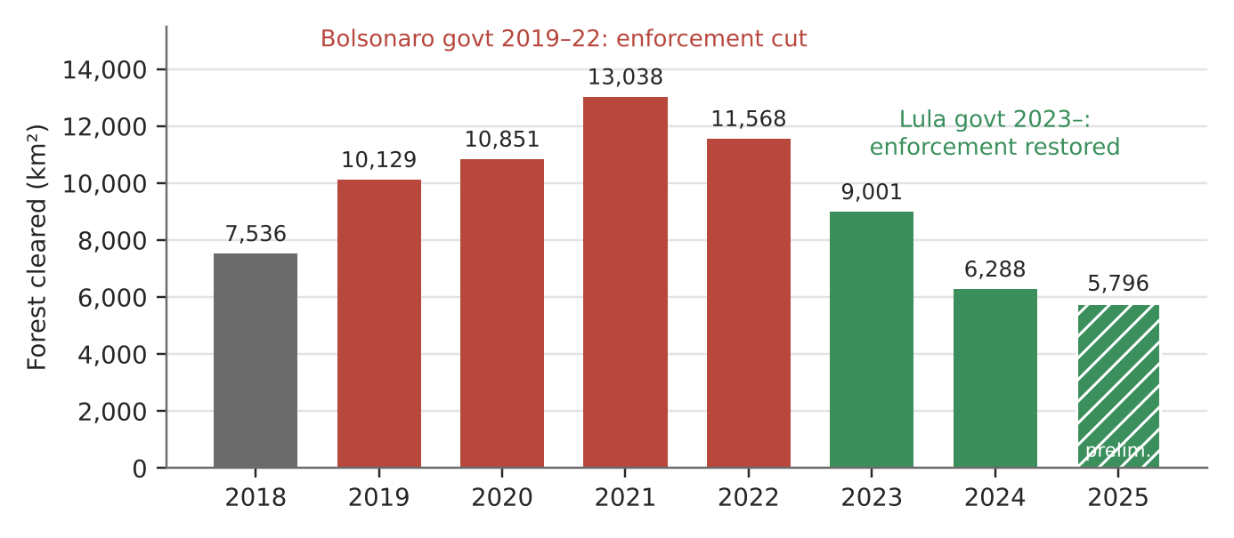
Figure 1. Yearly forest loss in the Legal Amazon (INPE PRODES, August–July years; 2025 is preliminary).
What happened
From 2019 to 2022 the Bolsonaro government cut the budgets of environmental agencies and weakened enforcement while backing farm expansion. Forest loss rose from 7,536 km² (2018) to 13,038 km² (2021), the highest since 2006. After Lula took office in 2023, enforcement returned and loss fell to 6,288 km² in 2024.
How it shows the trade-off
- Economic gain: agribusiness was 23.2% of Brazil's GDP and about half of its exports in 2024. Farm exports hit a record US$93.6 billion in January–November 2020. Most cleared land becomes cattle pasture (62% of the area cleared up to 2008).
- Environmental cost: each cleared hectare loses regulating services (carbon storage, rainfall recycling) and habitat. Loss stayed above 10,000 km² a year from 2019 to 2022.
- Social cost: about 20,000 illegal gold miners entered Yanomami land after 2019. About 570 Yanomami children died of curable diseases during Bolsonaro's term, and Brazil declared a health emergency there in January 2023.
Exam angle
- The trade-off is a political choice, not fixed. From 2021 to 2024, forest loss fell 52% while beef exports hit a record 1.14 million tonnes in the first half of 2024 (up 29%). Stronger enforcement weakened the trade-off without stopping growth.
- Use it to show that the three dimensions are interdependent: forest loss can hurt farming over time by reducing rainfall.
Sources
1. FAPESP – The return of deforestation (2018, 2019 rates)
2. eCycle/IPAM – PRODES 2021 and 2022 rates
3. INPE – PRODES 2021 technical note (2020 consolidated rate)
4. WWF-Brasil – 2024 rate, 30.6% fall
5. Mongabay – 2025 preliminary rate
6. ApexBrasil – agribusiness share of GDP
7. Agriland – record beef exports H1 2024
8. Solar Daily – 62% of cleared land used for cattle
9. CS Monitor – illegal miners on Yanomami land
10. Euronews – Yanomami child deaths, health emergency

1.1.1 Understanding SD — Factors (limits on meeting needs)
Case study: Cape Town 'Day Zero' water crisis, South Africa (2015–2018)
Syllabus: Limits on ability to meet present and future needs imposed by the current level of technology and the environment's ability to meet those needs.
Place | City of Cape Town, Western Cape
Period | Drought 2015–2017; crisis peak January–May 2018
Scale | Supply dams fell to about 21% in May 2018; taps were to be shut off at 13.5%
Key actors | City of Cape Town, national Department of Water and Sanitation, households, farmers
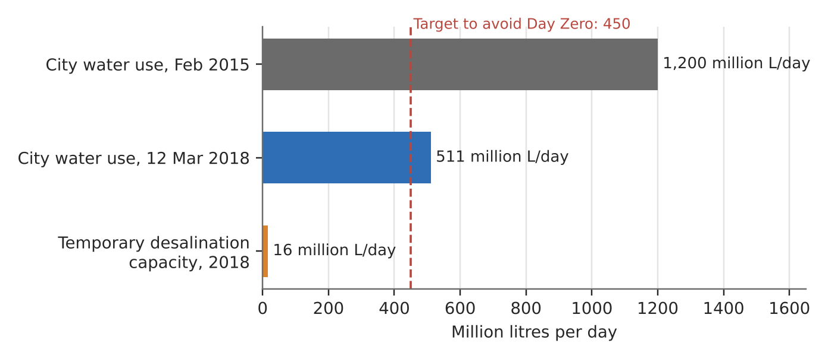
Figure 2. Cape Town's daily water use against the Day Zero target and the city's emergency desalination capacity.
What happened
Three dry years drained the rain-fed dams that supply the city. On 23 January 2018 the city set 'Day Zero', when most taps would be shut off, for 12 April 2018. A 50-litre per person daily limit (Level 6B) started on 1 February 2018. Day Zero was pushed back several times, and rains from June 2018 refilled the dams to about 70% by September.
How it shows the limits
- The environment's ability: the city relied almost wholly on surface dams fed by winter rain. A 2019 study linked the drought to the Hadley cell expanding towards the poles, so the limit may tighten with climate change.
- Technology: three small temporary desalination plants gave at most 16 million litres a day, about 3.5% of the 450 million-litre target. Other supply schemes would come online only after Day Zero, so technology could not close the gap in time.
- What worked was cutting demand: use fell from 1.2 billion litres a day (February 2015) to 511 million litres a day (12 March 2018), down 57%.
Exam angle
- The technology limit is about time and cost, not know-how. Desalination works, but it could not be built at scale within months.
- Evaluation: limits are not fixed. Behaviour change bought time until the rains came, but the city stayed exposed to the next drought.
Sources
1. Wikipedia – Cape Town water crisis (dam levels 14–29%)
2. News24 – Day Zero moved to 12 April; Level 6B 50 L from 1 Feb 2018
3. Daily Maverick/GroundUp – use fell from 1.2 bn to 511 m L/day
4. Pressreader (Cape Argus) – desalination plants on track
5. SIWI – How Cape Town saved itself from Day Zero
6. npj Climate & Atmos. Sci. – Day Zero drought and Hadley cell expansion
7. WWF – Cape Town: Avoiding Day Zero
8. Business Insider – Day Zero postponements

1.1.1 Understanding SD — Challenges (measuring progress)
Case study: Nigeria: 20 years without a census (2006–2026)
Syllabus: The difficulty of measuring progress towards sustainable development using quantitative indicators due to the lack of capacity of some countries to collect data.
Place | Nigeria (36 states)
Period | Last census 2006; 2023 census postponed; GDP rebased July 2025
Scale | Population estimates for 2026 range from 238 to 243 million, a spread of up to 5 million people
Key actors | National Population Commission (NPC), National Bureau of Statistics (NBS), the President, UN agencies, World Bank
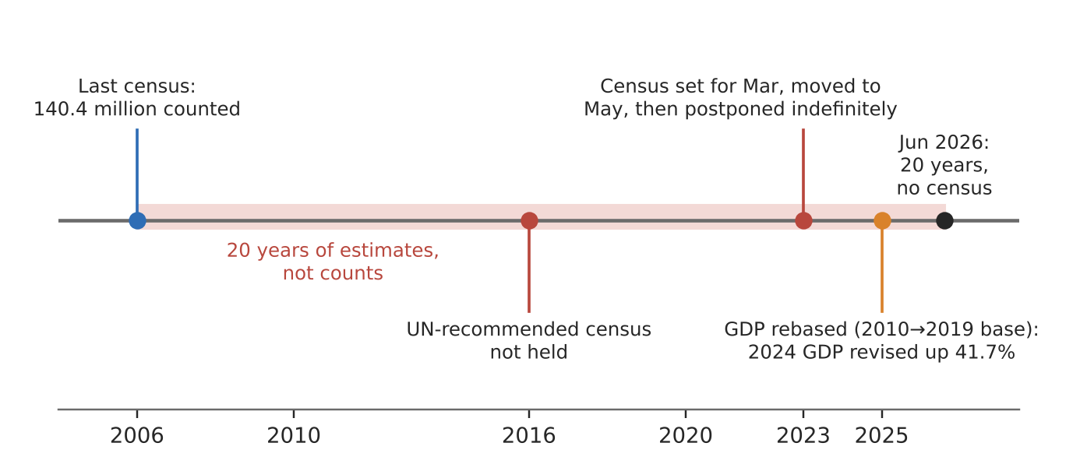
Figure 3. Nigeria's data timeline: one census in 20 years, and a GDP rebasing that changed the size of the economy overnight.
What happened
Nigeria last counted its people in 2006 (140.4 million). The UN-recommended 2016 census never happened. A 2023 census was set for 29 March, moved to 3 May, then postponed indefinitely; the NPC had put its cost at ₦546.72 billion. In July 2026 the NPC said the President must set the date, and it cannot fall in an election year (2027).
How it shows the challenge
- No reliable denominator: per-person SDG indicators (GDP per capita, poverty rate, school enrolment) all divide by population. For 2021 the UN gave 211 million and the World Bank 213 million.
- Economic data shifts too: in July 2025 the NBS moved GDP's base year from 2010 to 2019. 2024 GDP became ₦372.8 trillion, a 41.7% upward revision, mainly from informal and digital activity not counted before. Ratios such as debt-to-GDP changed overnight with no change in real output.
- Capacity is political as well as technical: census figures affect how oil revenue and political seats are shared among the 36 states, so the count is sensitive and keeps slipping.
Exam angle
- Lack of capacity covers money, skills and political will. Nigeria had most of a digital census ready but no date.
- Evaluation: capacity is uneven, not absent. The NBS rebasing used a detailed table of 46 industries and 217 products, so some data are improving while the basic population count is not.
Sources
1. allAfrica – Nigeria hits 20 years without census (Jun 2026)
2. Vanguard – NPC: date set by President, not in election year (Jul 2026)
3. ICIR – census postponement and data accuracy
4. Daily Maverick – census delayed to May, first in 17 years
5. Zikoko – UN vs World Bank population estimates
6. Africa Check – no confirmed census date
7. Bloomberg – GDP rises to ₦372.8 trillion after rebasing
8. Channels TV – GDP rebased, 41.7% revision
9. Techeconomy – what to know about NBS rebasing (46 industries, 217 products)

